# **SERVICENOW SWATCH BASICS:**

Swatch configuration Management Database (CMDB);

* @ ServiceNow Discovery
* @ Service Watch
* @ CMDB

1. Architecture of the ServiceNow Discovery:

ServiceNow is normally hosted in ServiceNow's data center, and it does not have the ability to access the enterprise's network – but Discovery needs access to do its job.

 Discovery uses special server processes (called MID Servers), that are installed on each enterprise network that has computers or devices to be discovered.

Discovery is simply to execute probes and return the results back to the ServiceNow instance for processing; it does not retain any information. In effect, a MID server is a remote extension of the ServiceNow instance, on an enterprise network.

MID SERVER

MID servers communicate with the ServiceNow instance they are associated with by a simple model: they query the instance for probes to run, and they post the results of probes they've completed back to the instance. There, the data collected by the probes is processed by sensors, which decide how to proceed. The MID server starts all communications, using **SOAP on HTTPS** – which means that all communications are secure, and all communications are initiated inside the enterprise's firewall. No special firewall rules or VPNs are required.

**PROBES** :

* **Probes** are launched by the MID Server to collect information about a device.
* The **probe** sends back information to the **sensor** to be processed. ... In both cases, the sensor updates the CMDB.
* A **MultiProbe** is a **probe** that contains **probes**. A **MultiSensor** processes the data from a **MultiProbe**.
* Discovery probes and sensors perform data collection and processing tasks.

Probes and Sensors work together:

* The **probe** sends back information to the **sensor** to be processed. ... In both cases, the sensor updates the CMDB
* If the probe has a post-processing script defined, the post-processing script does some data processing on the MID Server before data is sent back to the sensor on the ServiceNow instance.
* **MultiSensor** contains individual scripts to process the data returned by each probe contained in the **Multirole**, as well as a main MultiSensor script. The individual scripts pass their processed data to the main MultiSensor script

Additional Information for understanding purposes:

SERVICENOW INSTANCE ___> PROBES ---🡪 gets results of probes and posted to the instance

And the result is collected by the sensors 🡪mid server 🡪 proceeds on **SOAP on HTTPS PORT: 443**

* All communications are done inside the enterprise network .Discovery Plugin (Activate Plugin (com.snc.discovery) plugin.
* Multi Sensor Form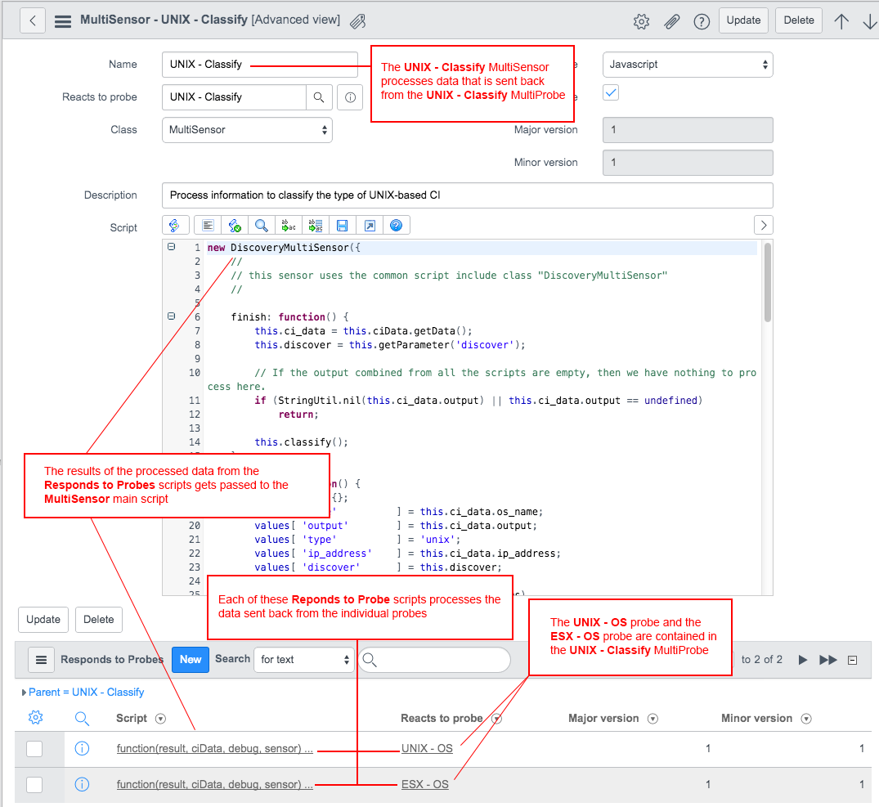

Probes and sensors have a major and a minor version

. All members of a MultiProbe bundle have the same major and minor version.

* A major version change reflects a change in the expected output of a probe, such as the addition or subtraction of a targeted attribute, a format change, such as XML versus JSON, or a probe parameter script change
* A minor version change reflects small fixes that do not impact the result or the processing of the data.

**Versions for MultiProbe and MultiSensors are checked as follows:**

* The versions of the individual probes contained in the MultiProbes are compared with the Responds to Probes scripts that process their data.
* The versions of the Responds to Probes scripts and the main MultiSensor script are compared.

**Important**

* If the major version is the same, but the minor version is not, a sensor processes information during a discovery.
* If a probe and its corresponding sensor do not have the same major version, a sensor does not process information during a discovery and sends error messages to the log file. Errors also show up on the Discovery Dashboard when you run a discovery job.

**Discovery**:

**Discovery** > **Quick Start**

Discovery Quick Start is intended for initial, one-time setup.

# **Stages:**

**MID Server User**: Create the MID Server user that has permission to connect to the ServiceNow instance.

**Install MID Server**: Install the MID Server and configure it for your environment.

**Credentials**: Create the credentials that the MID Server needs to communicate with devices in your network.

**Schedules**: Schedule a Discovery.

**Confirmation**: Display a summary of the Discovery settings to make sure your configuration is correct.

## **Configure the MID Server user**

Role: admin, discovery_admin

* Enter the user name and password of the account under which the MID Server runs.

* The system creates the user in the User [sys_user] table and assigns the mid_server role.

# Stages Explanation:

## **Install the MID Server**

* Role required: admin, mid_server

## **Create credentials**

* Create and test the credentials that the MID Server needs to access the devices in your environment.
* Role required: admin, discovery_admin

## **Create a schedule for the Discovery quick start**

* Determine when Discovery should run and define the IP address ranges it should explore.

## In the Schedule stage, create a schedule with a unique name and enter the IP address range for the discovery.

## **Confirm the Discovery**

* After you exit the quick start, you cannot reopen it.
* Click **Discover Now** to run Discovery immediately or **Go to Dashboard** to display the Discovery dashboard.

**SERVICE WATCH SERVICE MAPPING**

Service Watch enables IT to manage services instead of servers and improve the level of services we offer.”

ServiceNow Service Watch has an innovative top-down approach to discovering and mapping the relationships between data center components that comprise specific business services, providing insights into how those services are delivered and how they are performing.

IT organizations need to build service maps. These maps identify all of the IT components that support a service—along with the relationships between these components.

ServiceNow® Service Mapping provides IT with visibility into the IT infrastructure that makes up business services.

It creates accurate service maps, using traffic based discovery and infrastructure information in the ServiceNow® Configuration Management Database (CMDB) to show the mix of applications, IT components, and cloud services that support a service and how they are related.

Advanced service mapping Service Mapping uses traffic-based discovery to automatically generate initial maps and then uses machine-learning to refine results.

ServiceNow CMDB integration Service Mapping is also tightly integrated with the ServiceNow® CMDB, populating service maps into the CMDB to create a service-aware single system of record. This provides other ServiceNow applications with information that makes them service-aware

<https://www.servicenowelite.com/blog/2015/11/10/what-is-service-watch>

## WHAT IS SERVICE MAPPING?

"ServiceNow Service Mapping has an innovative, “top-down” approach to discovering and mapping the relationships between IT components that comprise specific business services, even in dynamic, virtualized environments.”

[ServiceNow Information site for Service Watch](http://www.servicenow.com/products/servicewatch.html)

## HOW IS THIS DIFFERENT THAN SERVICENOW DISCOVERY?

ServiceNow Discovery uses a "bottom-up" approach to discovery.  With ServiceNow Discovery, you setup credentials and IP Range sets to discover CIs and some relationships based on those IP Ranges upward.

ServiceNow Service Mapping uses a "top-down" approach.  You setup a Business Service "entry point" such as an urn and it traverses down from that entry point to discover the CIs and relationships for that business service.

## HOW DOES SERVICE MAPPING HELP YOU?

Typically Business Service to CI relationships are maintained manually as they are not discovered.  The issue with these manual relationships is that as you soon as you are finished creating them, they quickly become out-of-date.

ServiceNow Service Mapping uses a top down approach to discovery.  By using this approach, you can specify a Business Service entry point and find all the CI and relationships underneath.

## OBSTACLES TO SERVICE MAPPING SETUP

1. **Mid Server install.**In order to discover CI and relationship information with Service Mapping.
2. **Entry Point Setup.**With traditional ServiceNow Discovery, you setup IP Ranges and credentials. And it if they are configured correctly, it will discover you’re CIs.  With Service Mapping, you need to know what entry point type to use and what entry point parameters to use for each business service to discover.  You have to also setup IP ranges on the collector. It is more detail-oriented than ServiceNow Discovery in my opinion.
3. **Collector Setup.** Collectors have xml files that say what IP ranges to use and what data to send to Service Mapping and ServiceNow.  Unlike ServiceNow discovery, where you configure these details within ServiceNow, you need to login to a server and configure these xml files.  Setup of collectors is dependent on your ServiceNow version

## ALL ABOUT THE BUSINESS SERVICES

Usage of Service Mapping all depends on your usage of business services.  If your business services are used in ServiceNow or wanted to be used, this can have a lot of benefit.  Manually setting up the relationship between CIs and Business Services is a really maintenance intensive and error prone process.   Being able to automate those relationships can save a lot of time and increase accuracy.

## **Configuration Management Database**

To effectively manage and improve your systems, you need to know exactly what assets are in your IT environment and have current, accurate configuration data. With an accurate configuration management database (CMDB), it's easy to understand your organization's IT environment, particularly in the areas of service impact analysis, asset management, compliance, and configuration management.

The ServiceNow® CMDB provides a single system of record for IT. When paired with ServiceNow Service Mapping, the CMDB becomes service‑aware—which enables your ServiceNow applications to be service‑aware as well. Now with your CMDB, you gain full visibility of your infrastructure and services, leading to more control of your environment and better decisions.

## **CMDB data model**

* The Configuration Management Database (CMDB) is a series of tables that contain all the assets and business services controlled by a company and their configurations. Configuration items such as computers and other devices on the network, software contracts and licenses, and business services are represented.
* The following figure represents the first few levels of the CMDB tables. These tables represent the class or type of the configuration items.
* **Note:** Some parts of this model might not be up to date. For example, the Base Configuration Item [cmdb] table which is the parent of Configuration Item [cmdb_ci], isn't showing.
* 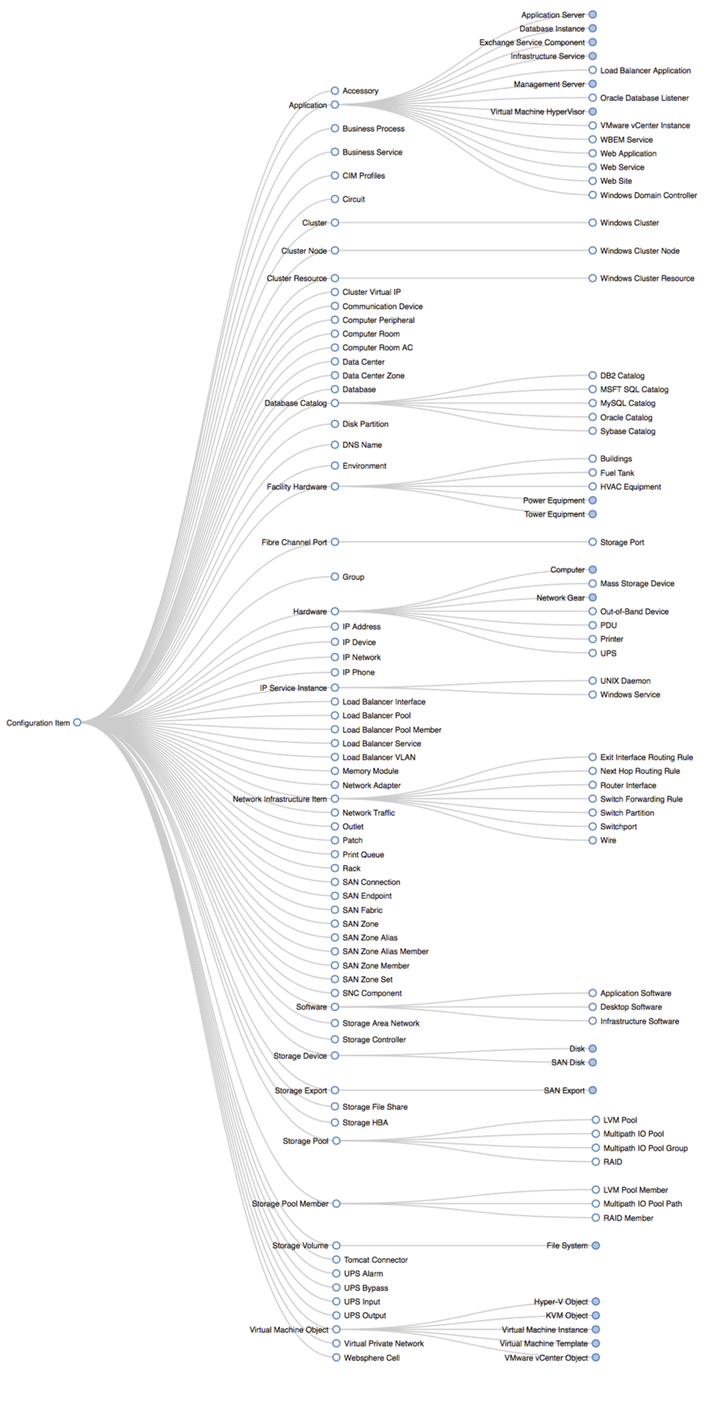

## **CMDB relationships**

The ECMDB lets you easily track all relationships by relationship type.

The Enterprise CMDB extends the capabilities of the ServiceNow platform CMDB in the following areas.

## **Extended configuration item types**

* Clusters
* Database Instances (Oracle, MySQL, MSFT SQL Server)
* File Systems (Direct and network attached)
* Linux Servers
* Solaris Servers
* AIX Servers

## **Extended relationships**

 ECMDB provides many relationship types out of the box, but it is easy to extend the number of relationship types. Example relationship types include the following.

* Connects to
* Depends on / Provides Service to
* Powered by / Powers
* Protected by / Protects
* Disaster Recovery Provided by / Provides Disaster Recovery for

## **Auditing**

Auditing of changes to configuration items is turned on by default.

## **Federation**

Federation of third party discovery and configuration data is supported through standard synchronization offerings (SMS, LAN Desk, others) and through the CMDB Discovery [cmdb_discovery] table.

## **Configuration item modeling (product models)**

Model driven configuration management allows the definition of CI models up front that can be associated to product maintenance lifecycles, cost centers, and support organizations, as well as provides a means for capacity and inventory planning. By defining models for CIs (which have a many to one relationship to the model), you can dynamically group actual discovered or imported CIs into logical, operational, and financial models. This facilitates an organized approach to managing your assets (CIs) in their respective domains.

## **Business service tables**

In the CMDB, the Business Service table [cmdb_ci_service] stores information about business services.

## A business service is work or goods that are supported by an IT infrastructure. For example, delivering email service to an employee can require services such as email servers, web servers, and the work to configure the user's account. A business service management map graphically displays the configuration items (CI) that support a business service and the relationships between the configuration items. **The Service Configuration Item Association table**

The Service Configuration Item Association table [svc_ci_assoc] binds a business service and a configuration item (CI) to track which CIs are part of each business service.

| **The Service Configuration Item Association table** | |
| --- | --- |
| Field | Description |
| Configuration Item Id | A reference to the configuration item [cmdb_ci] table. |
| Service Id | A reference to the business service [cmdb_ci_service] table. |

## **The Service Relationship Association table**

The Service Relationship Association table [svc_rel_assoc] binds a business service and a relationship to track which relationships are part of a business service.

| **The Service Relationship Association table** | |
| --- | --- |
| Field | Description |
| Relation Id | A reference to the CI Relationship [cmdb_rel_ci] table. |
| Service Id | A reference to the Business Service [cmdb_ci_service] table. |

## **Table form views**

 For any class that is an extension of the CMDB table, you can select the CI Definition view which provides additional access to related tables and information.

CI Definition form view provides the following controls,

| Control | Description |
| --- | --- |
| **Icon** tab | View and create new NG-BSM icons for CI types |
| **CI Identifier** tab | View and create new CI identifiers |
| **Reconciliation Definitions** tab | View and create new data source definitions |
| **Inclusion** related link | Links to the Service Rules Metadata Editor |

To access these additional controls on the CI Definition form view, you need to first create a new table that is derived from the CMDB table, and then view it using the CI Definition form.

## **Contract Management**

Manage and track contracts with the Contract Management application in the ServiceNow platform.

A contract is a binding agreement between two parties. In the ServiceNow platform, contracts contain detailed information such as the following.

* Contract number
* Contract start and end dates
* Active status
* Terms and conditions statements
* Documents
* Renewal information
* Financial terms

**SERVICENOW CMDB**

 To ensure the data is correct, there needs to be structure. ServiceNow CMDB provides a single system of record for IT and as technology partners, Dynatrace & [Cognizant](http://www.cognizant.com/) offer an intelligent and automated solution to maintain quality in the CMDB.

Architecture

* Prioritize critical business services being impacted.
* Detect anomalies through artificial intelligence capabilities.
* Determine service outages efficiently with root-cause problem detection.

Service now overview

These records(details entered in the form ) operate using vmware vcenter instances ,and virtualized by the ESX Servers.The details form and its section which schematically shows the details pertaining to registration , operation and virtualization.

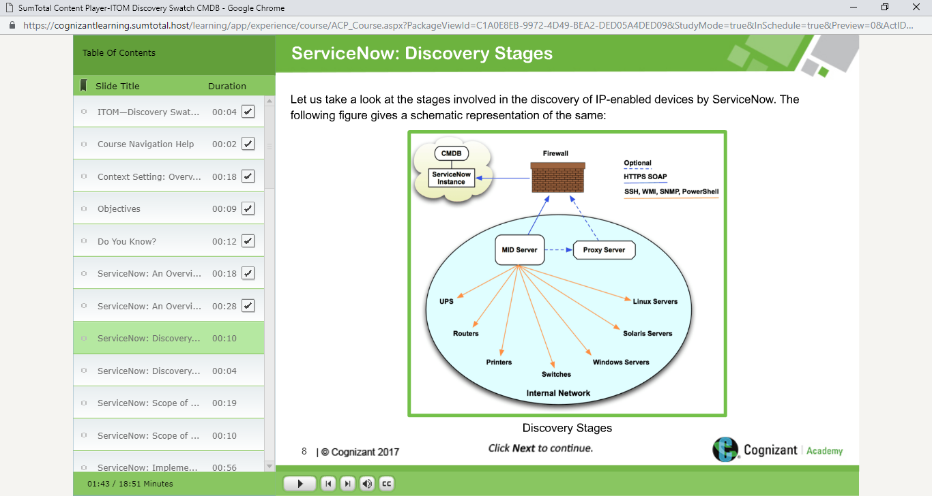

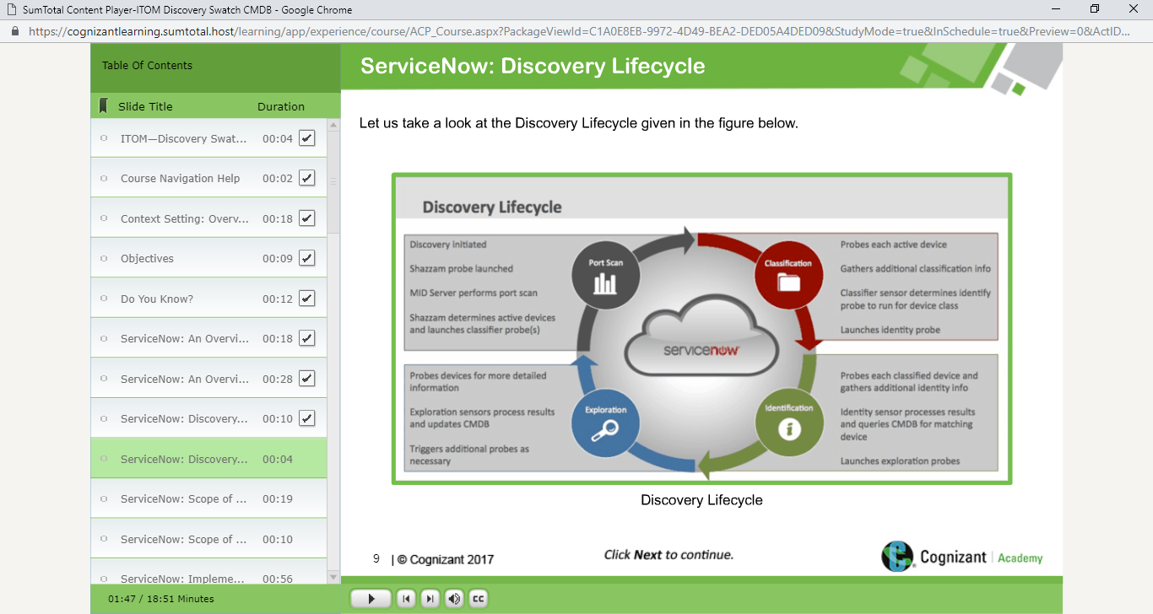

Different servers that fall within the scope of ServiceNow’s ability to identify the IP-Enabled devices.

* Windows and Linux servers
* Network devices , such as routers , switches and load balancers
* Virtual machines
* Storage boxes

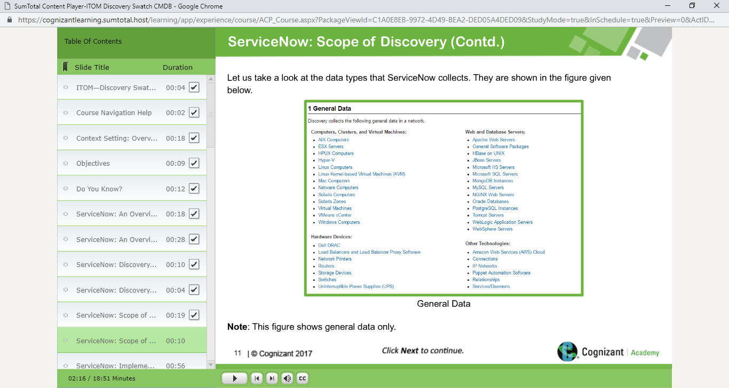

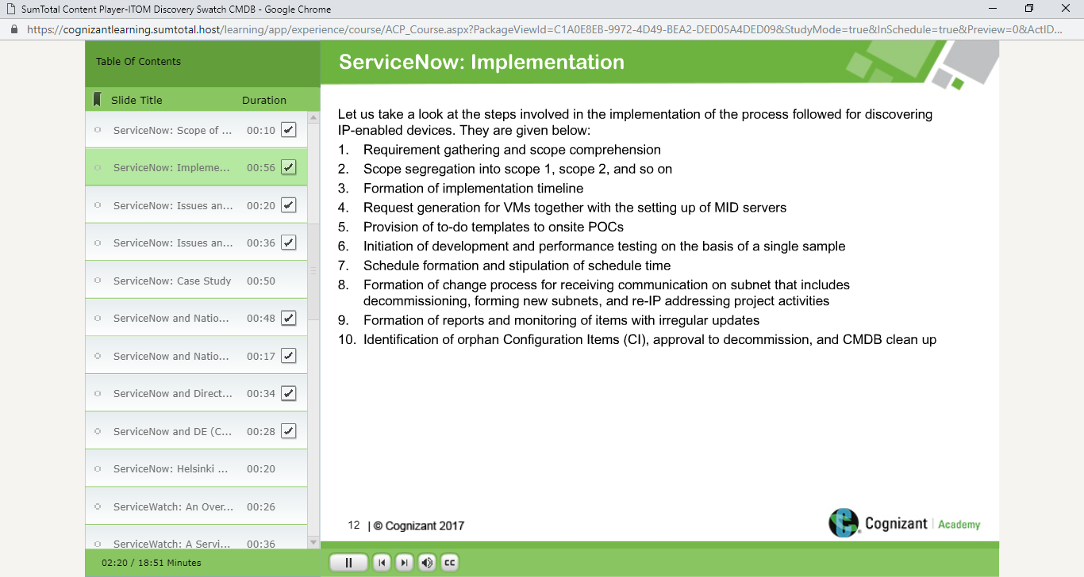

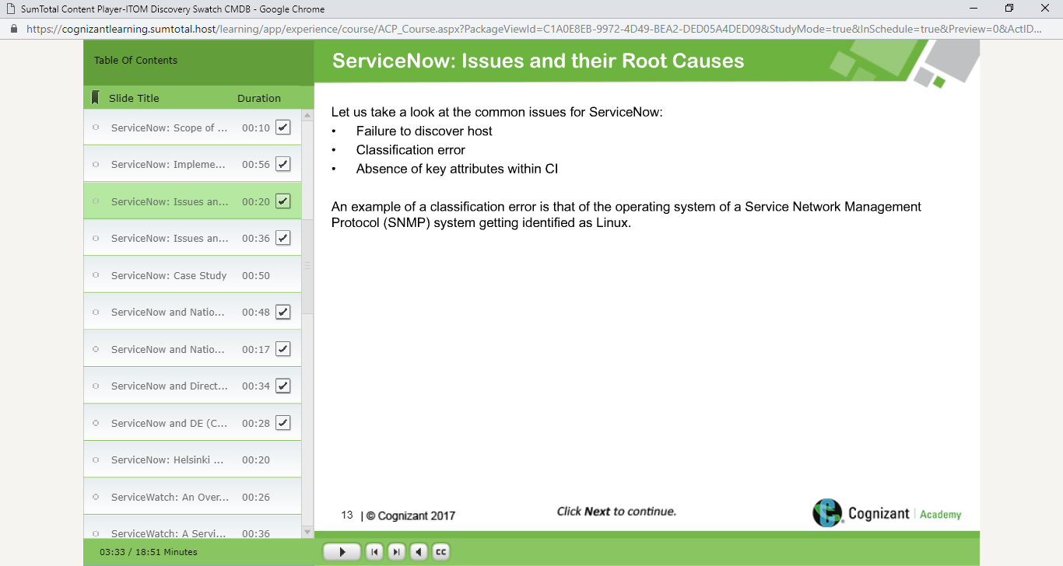

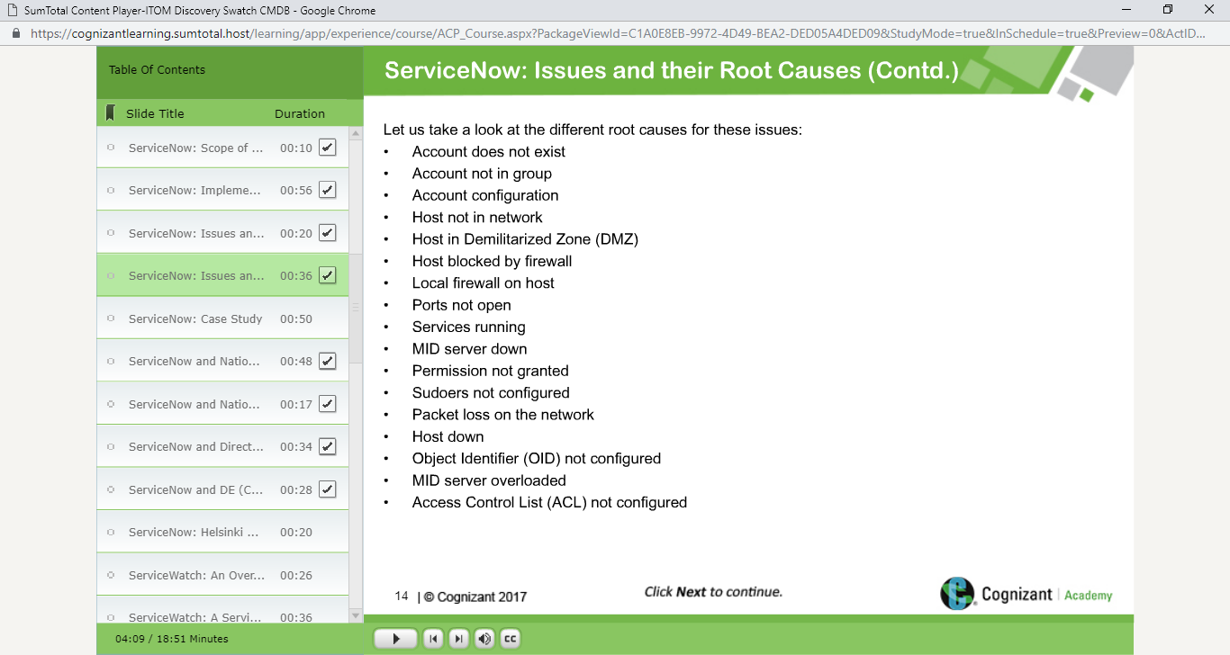

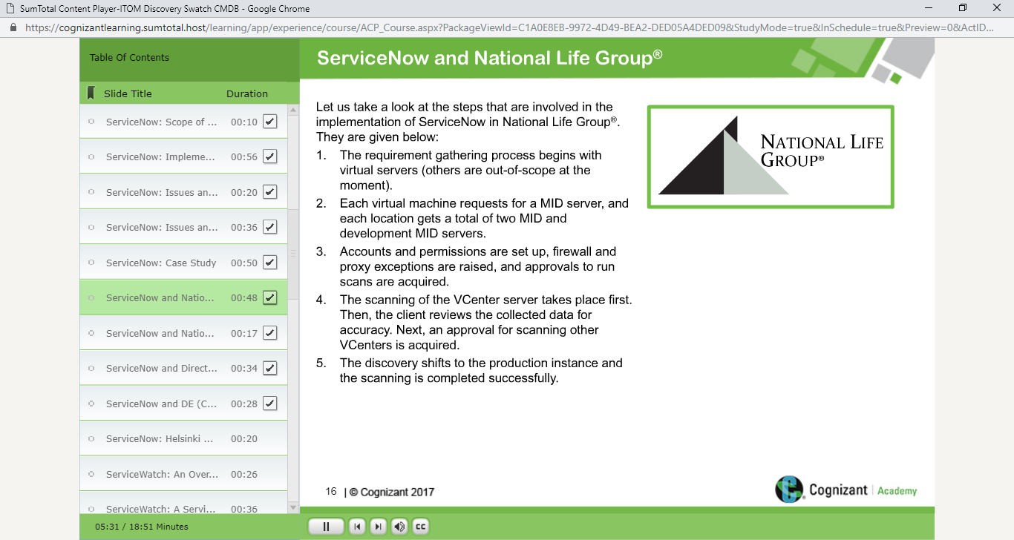

The ongoing requirement involves the tagging of the user to the asset informatino which is required for the client.

The approach involves two activities.

The identification of a windows shell command which tells the ‘user’who is tagged to the ‘asset’.

The population of the CMDB.

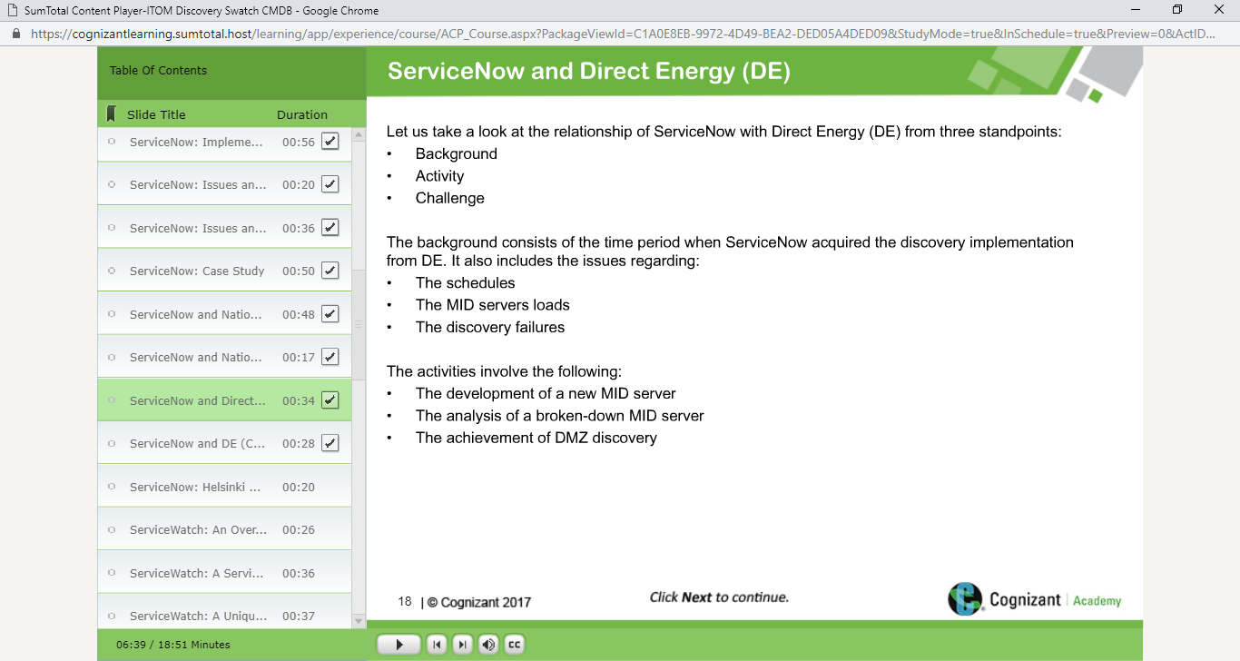

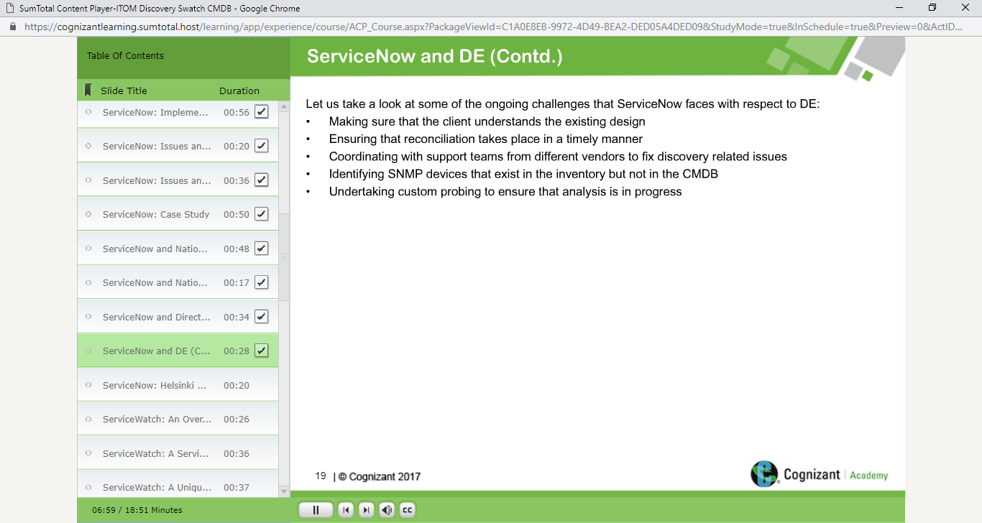 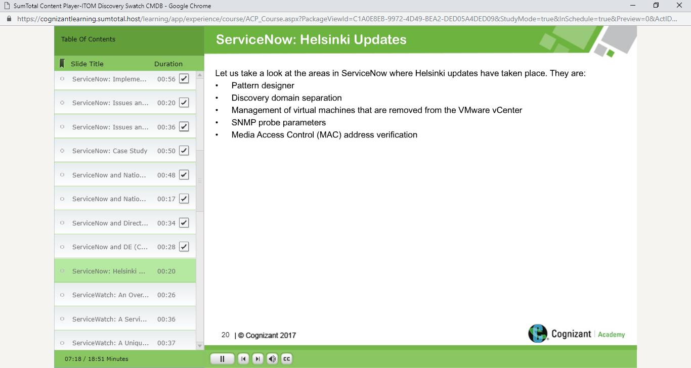

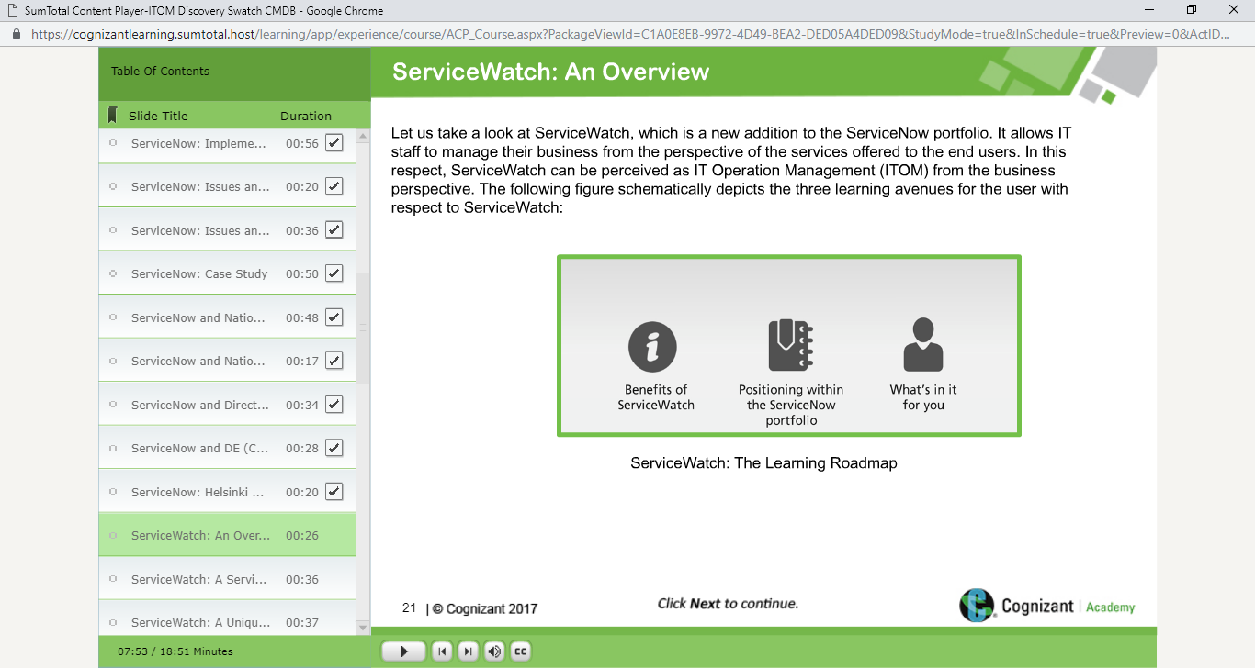 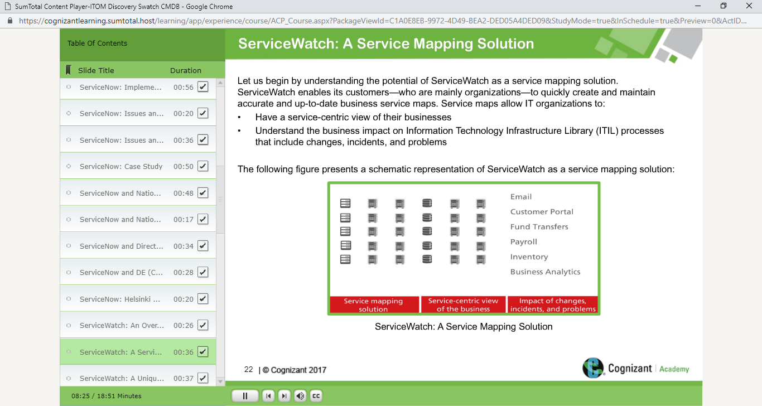

 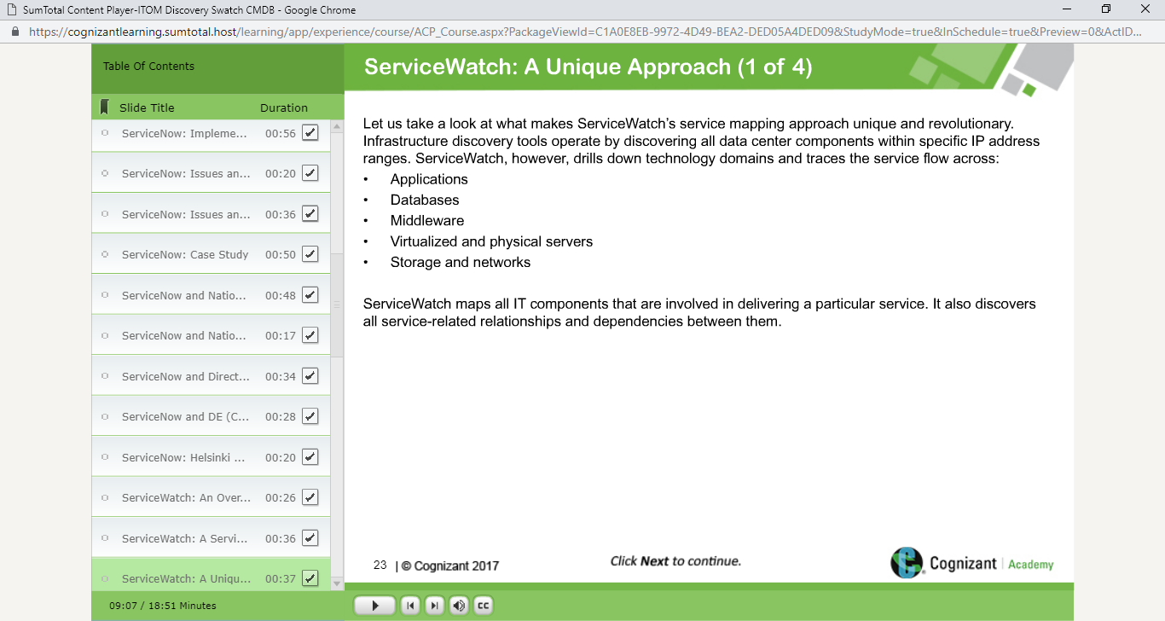

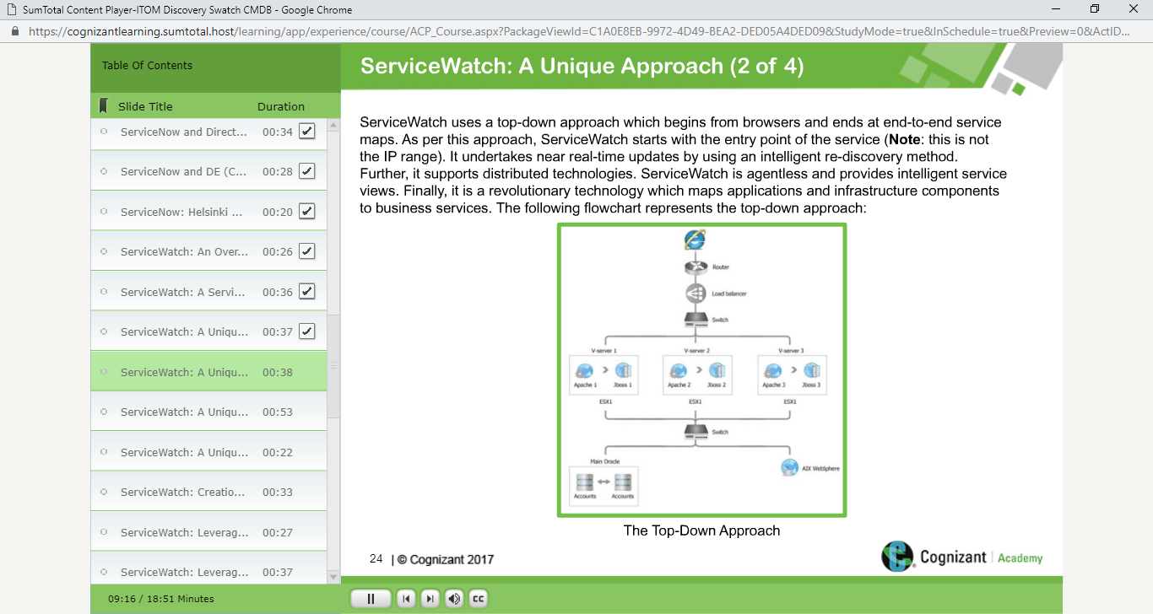

Service Watch

Service Watch🡪 Entry Point .

IT undertakes near real-time updates by using an intelligent re-discovery method.

Further , it supports distributed technologies ,ServiceWatch is agentless and provides intelligent servie views.

Finally , it is a revolutiionary technology which maps applications and infrastructure components to business Services.

The Above flow chart explains the top- down approach.

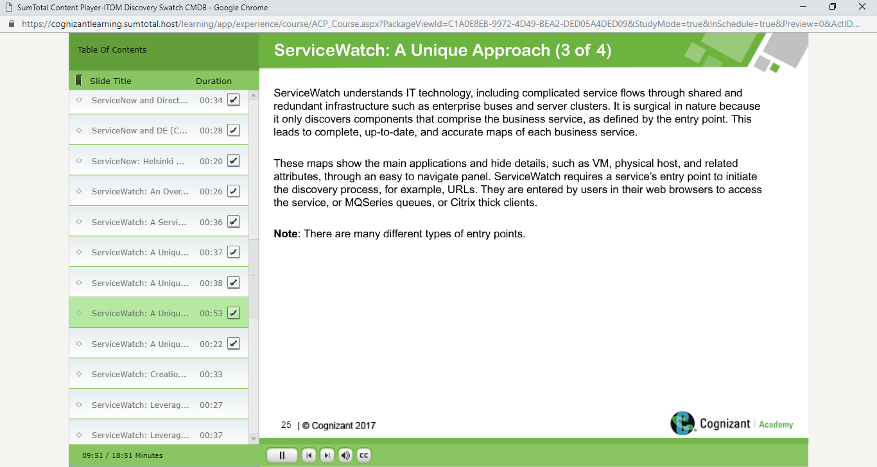

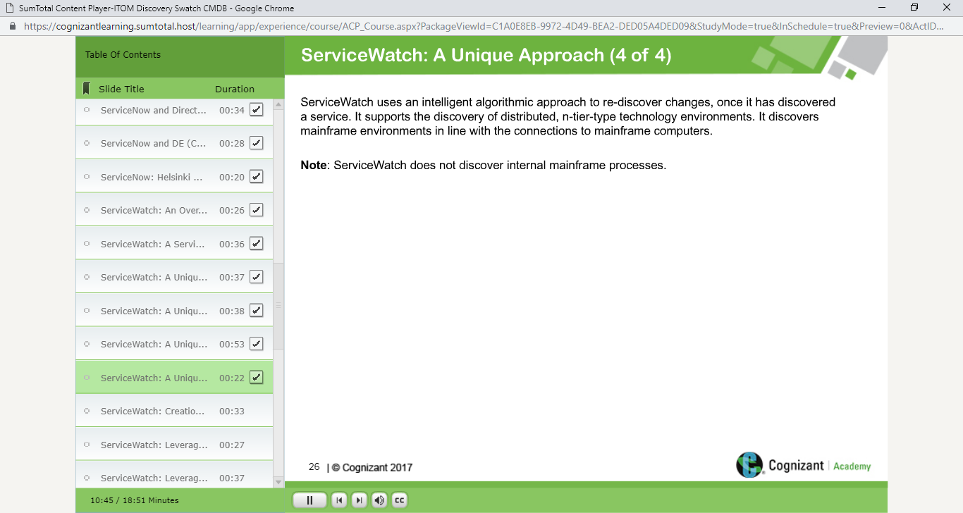

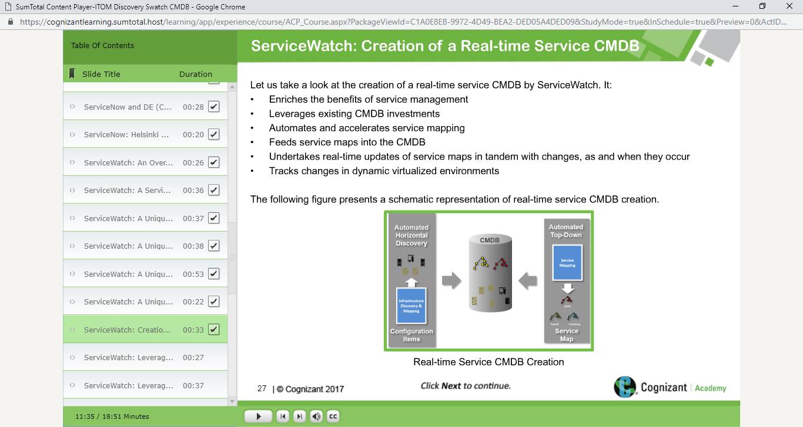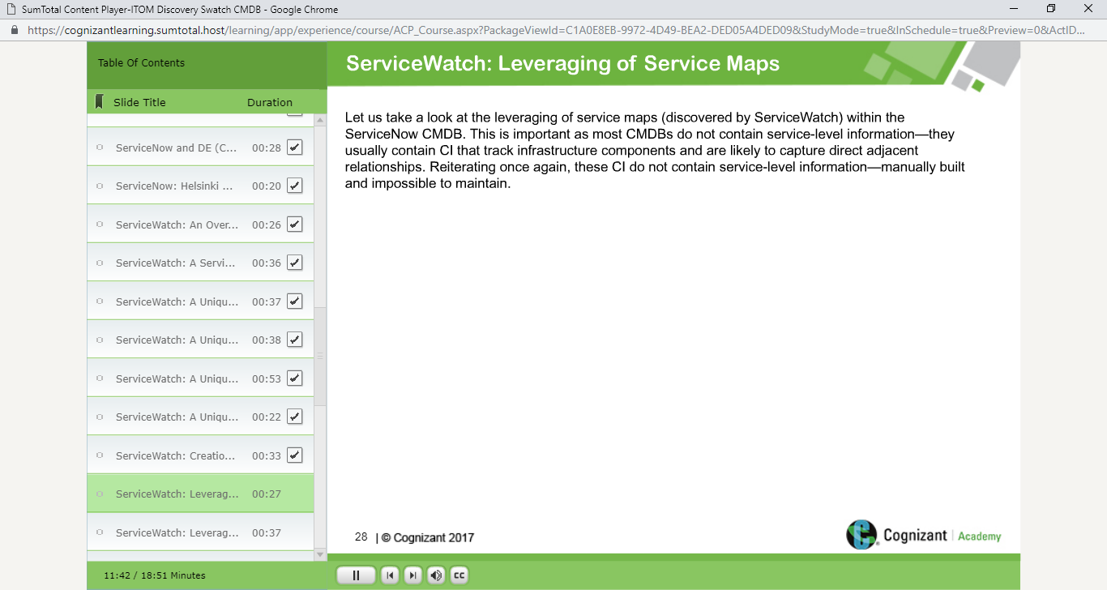

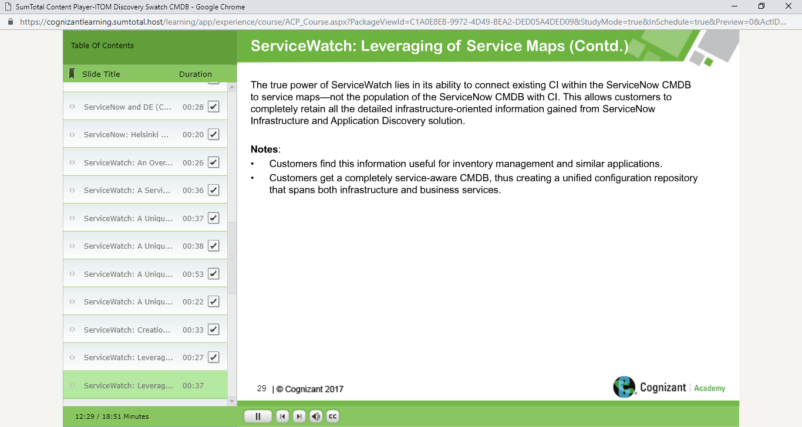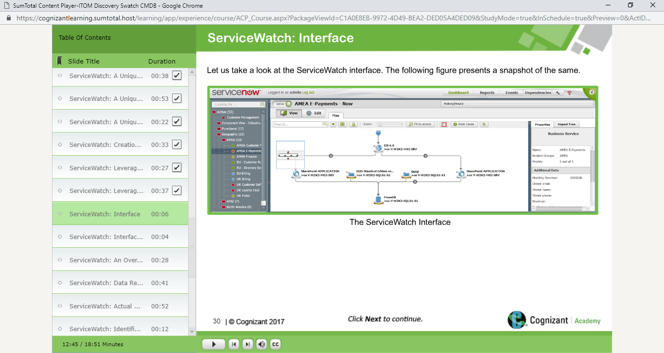

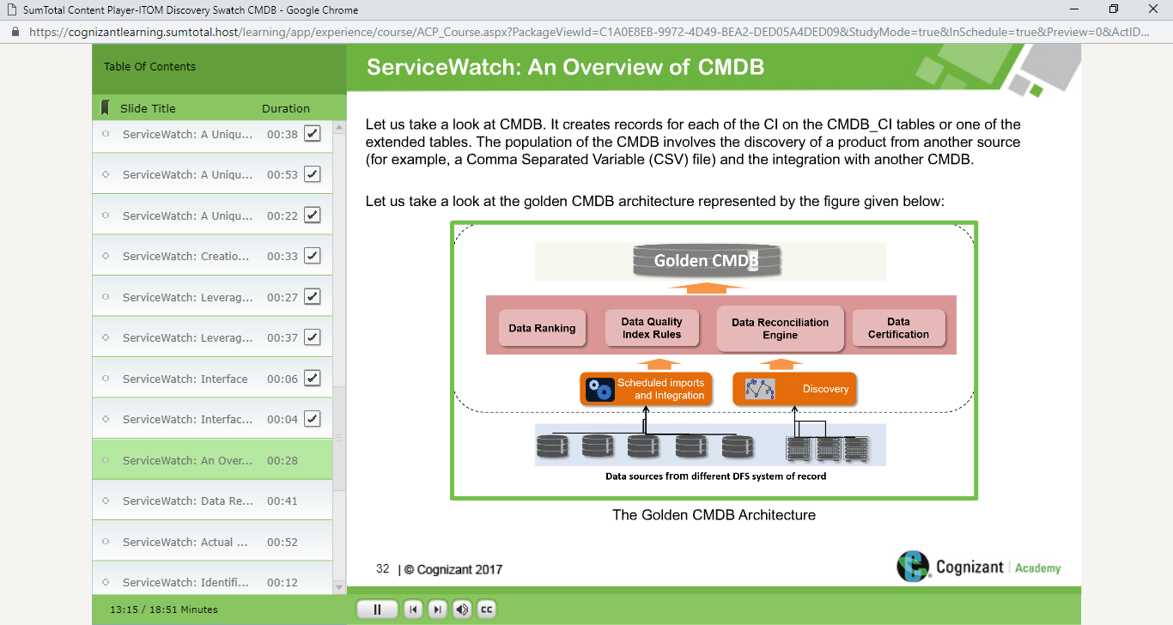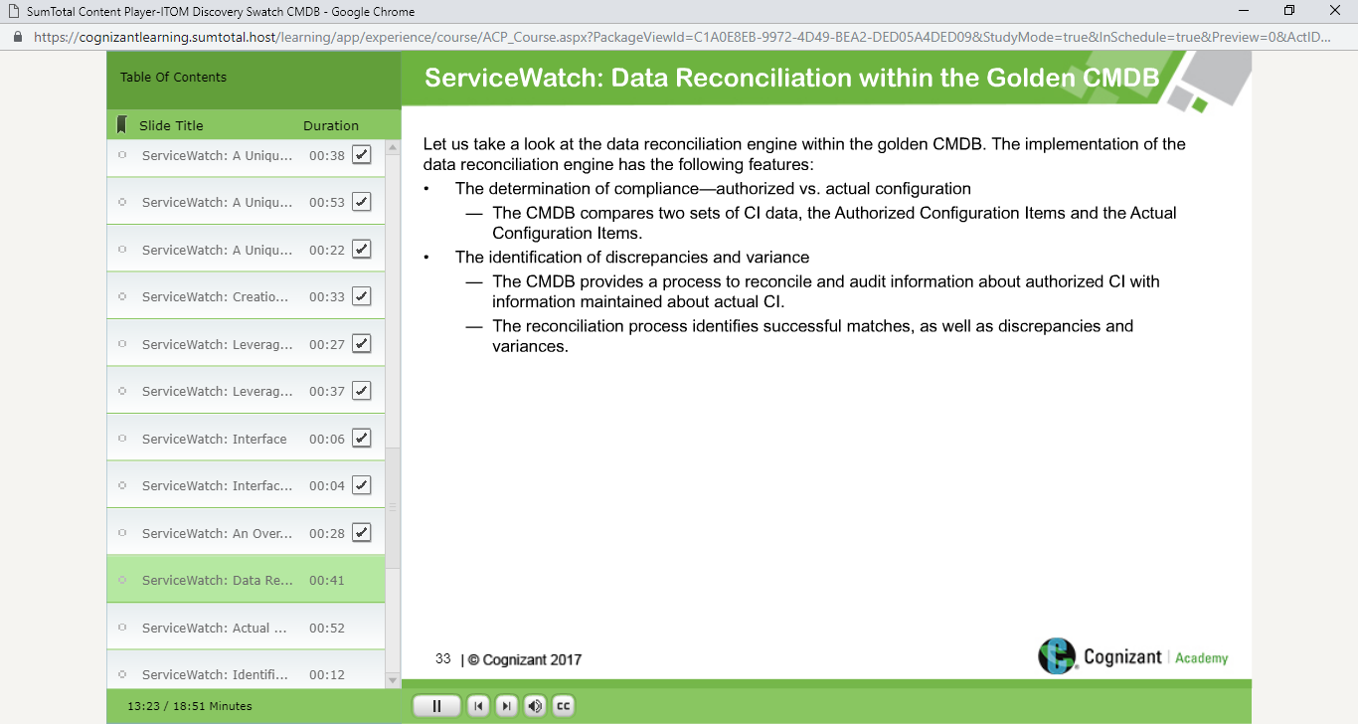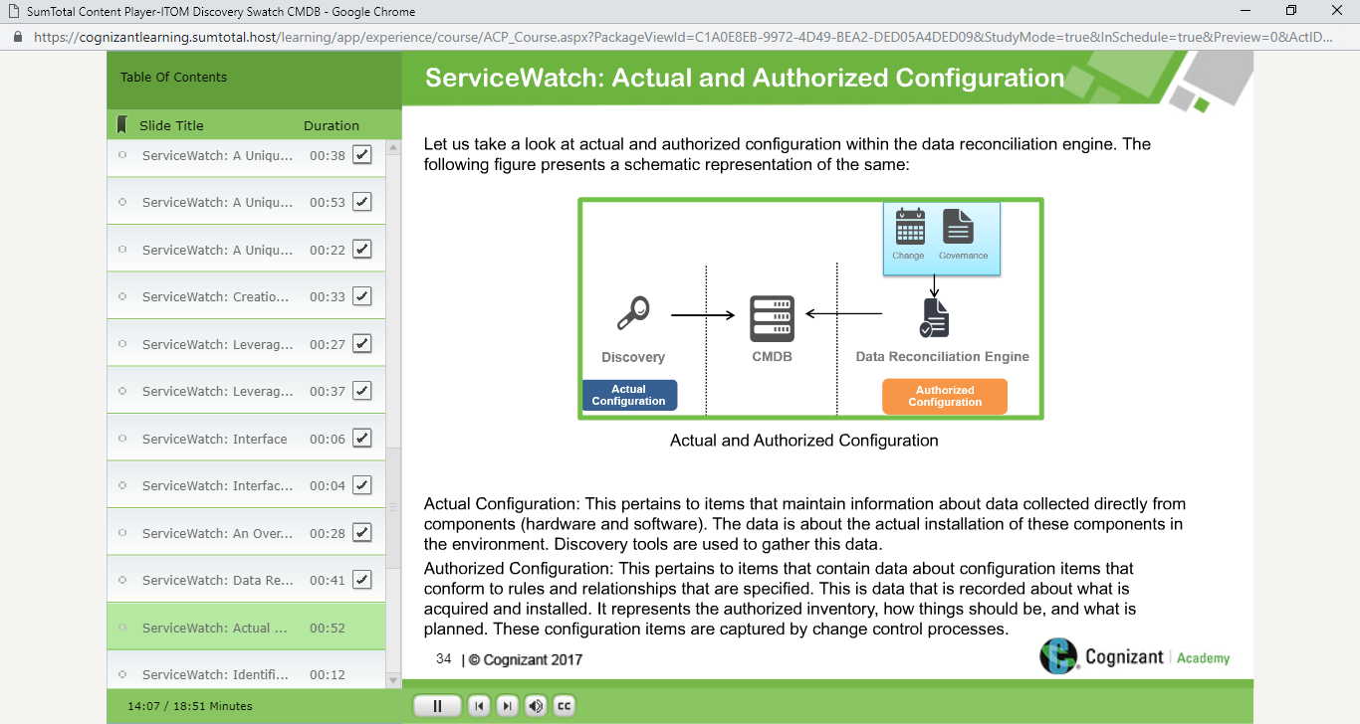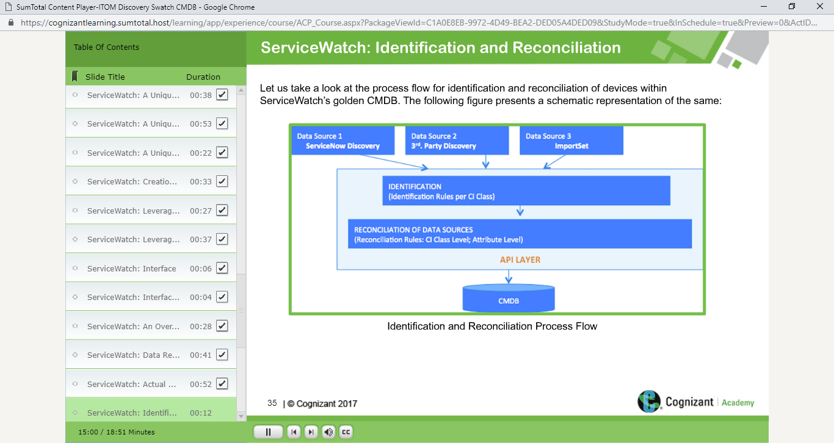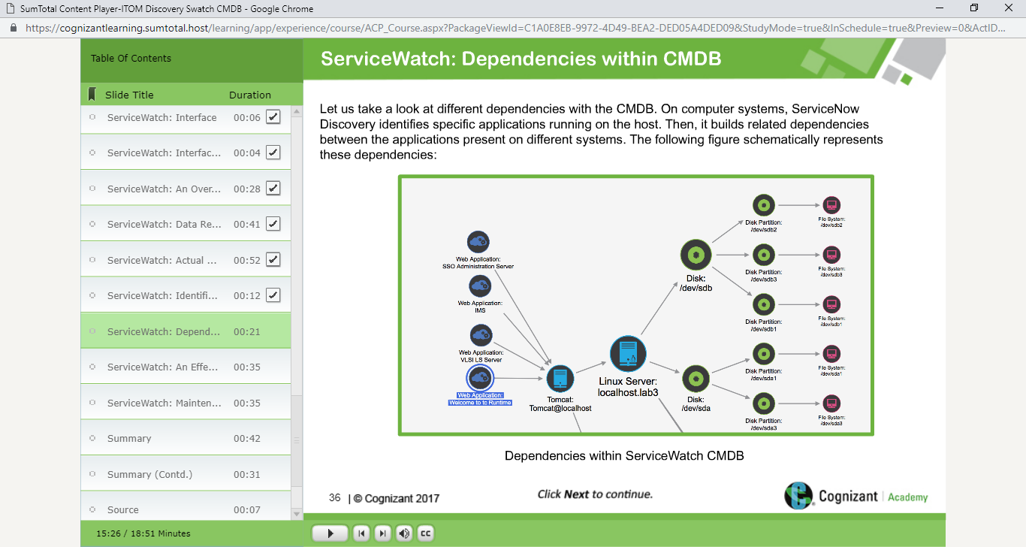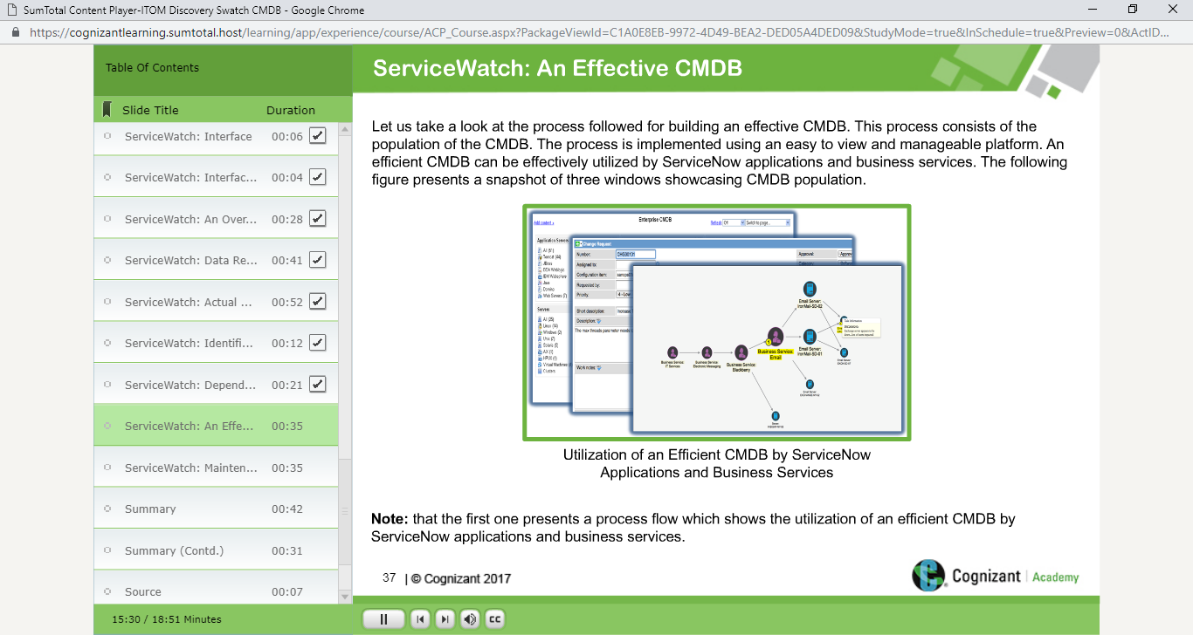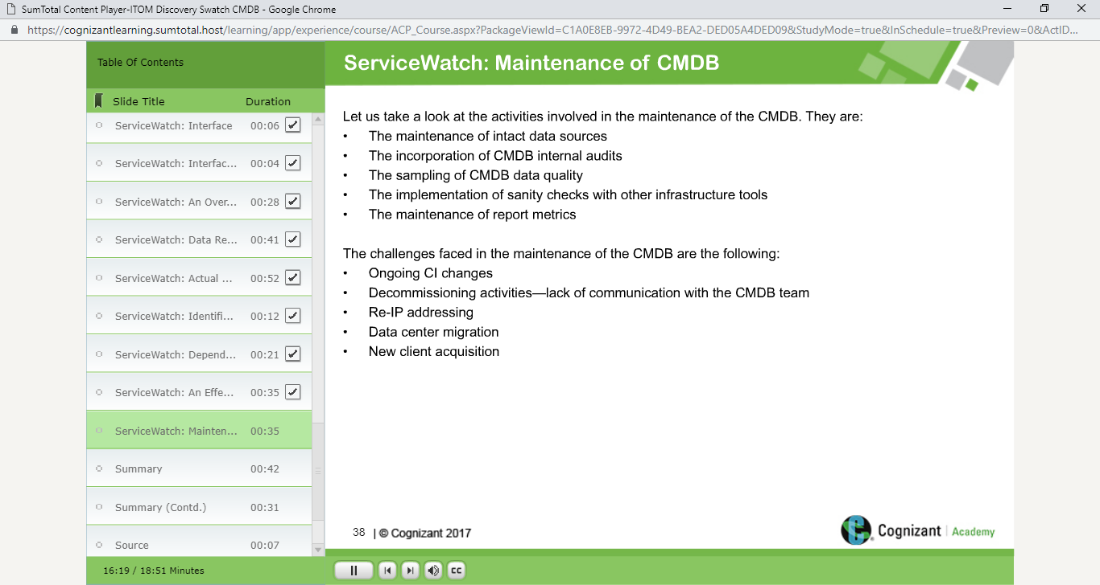

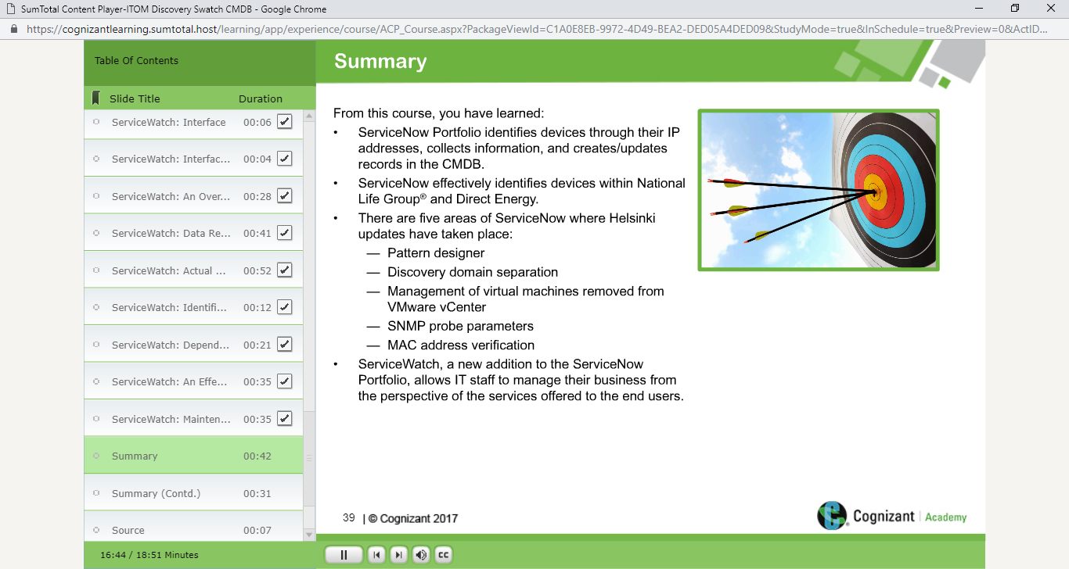

**SERVICE MAPPING MODULE CONCEPT STARTS**

